**EXPERIMENT 7**

**Create a simple cloud software application for a student attendance System using any Cloud Service Provider to demonstrate SaaS including the necessary fields such as name of the students, course, present, Absent, course attendance, OD request, grade, attendance percentage, etc.**

STEP 1: ENTER APPLICATION NAME

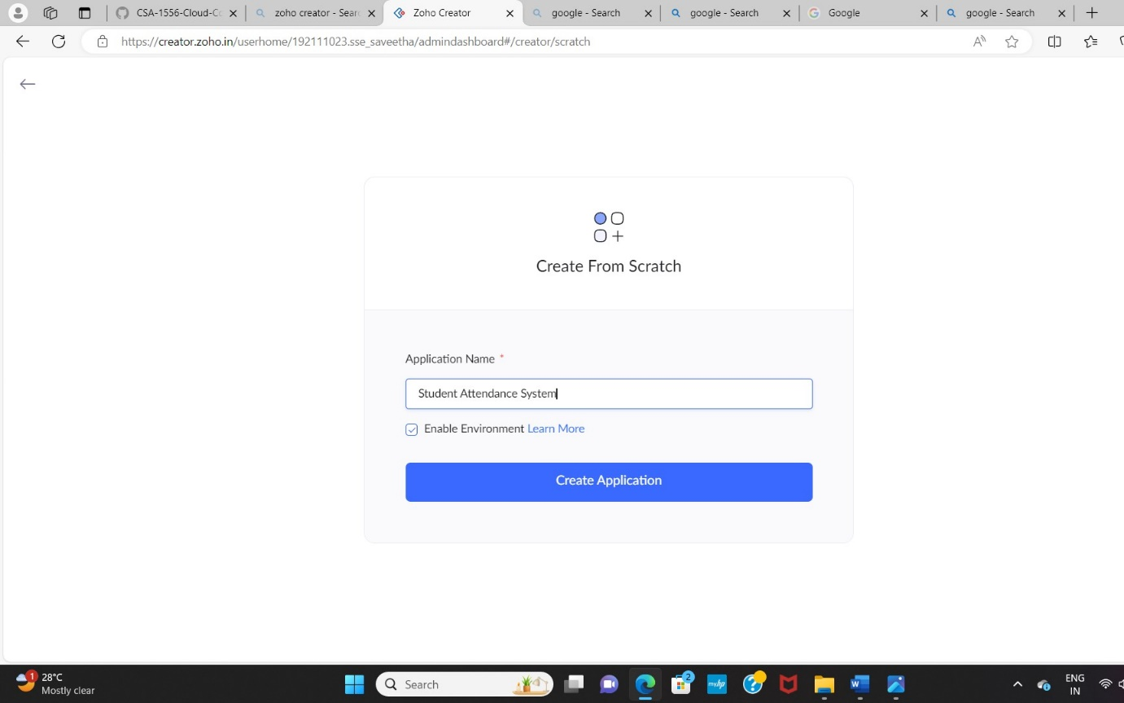

STEP 2: CREATED NEW APPLICATION

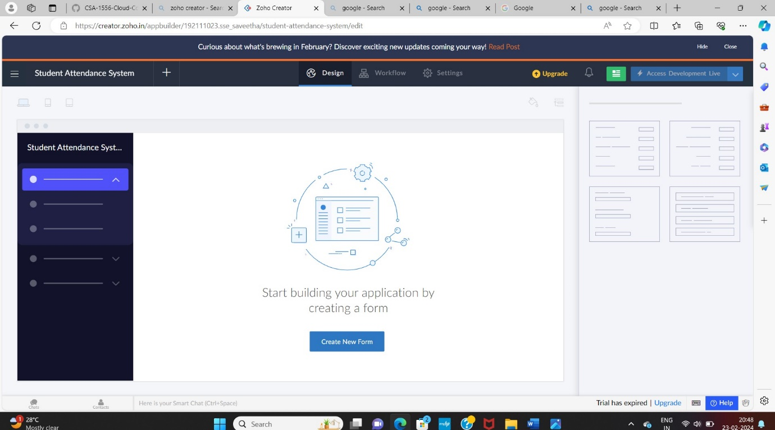

STEP 3: The form has been created as login.

Choose the fields.

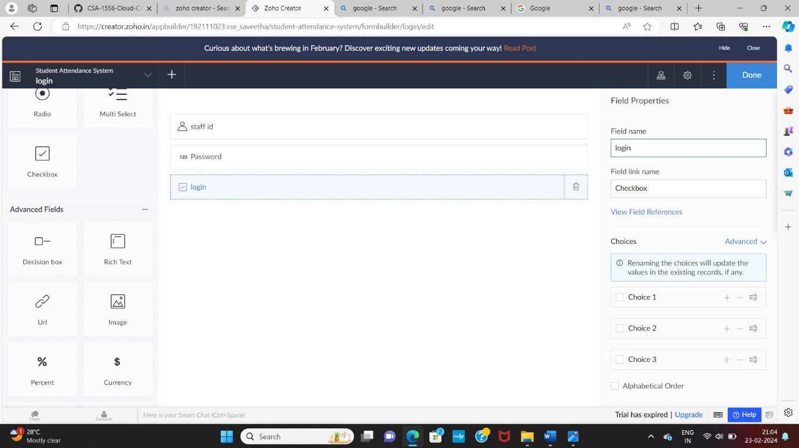

STEP 4: Click Access Development Live and enter the details to access.

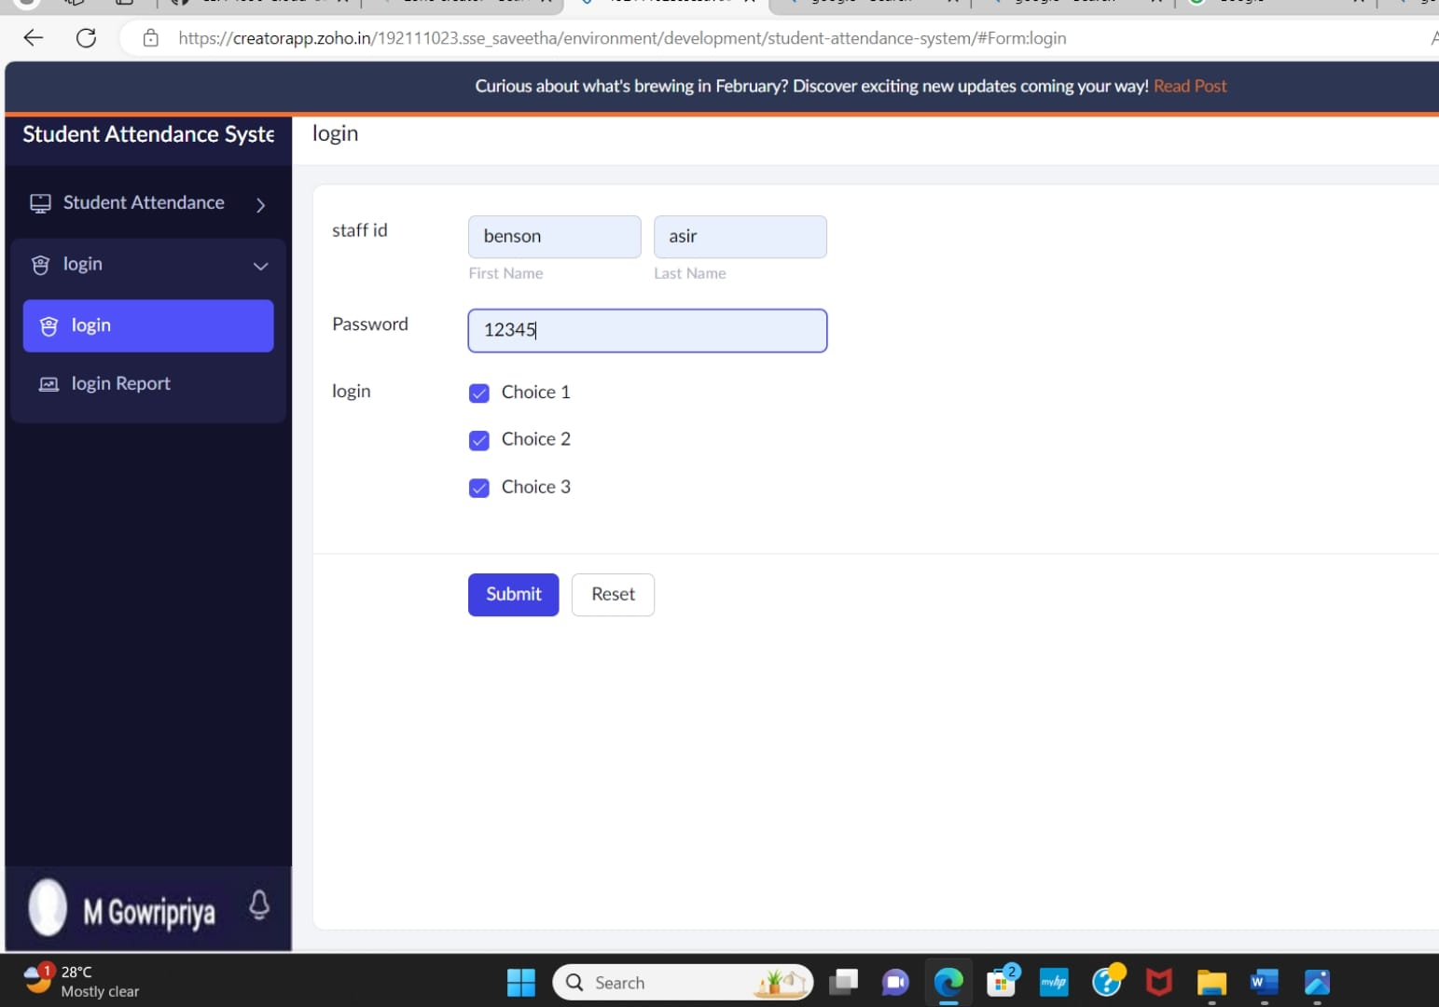

STEP 5: The report has been registered in the login report.

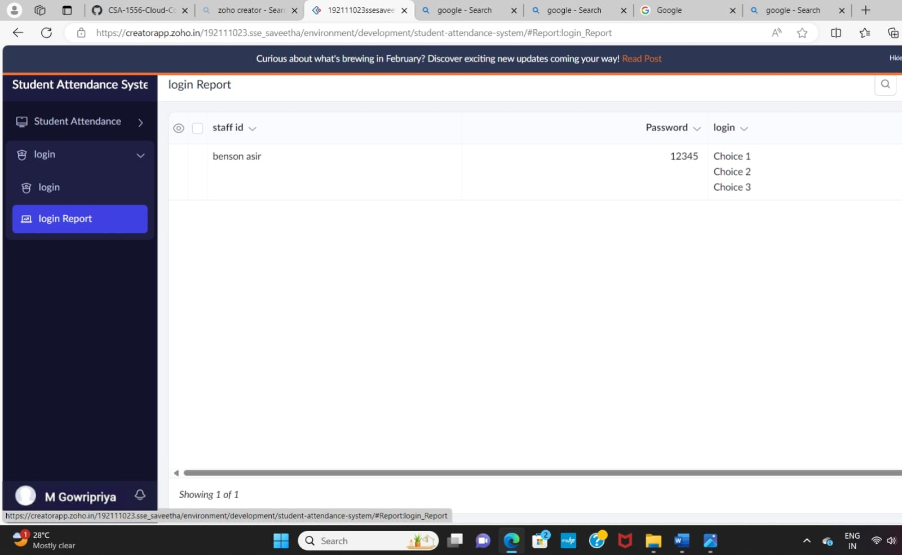

STEP 6: Create a form as Fill Attendance form

STEP 7: The form has been created as Fill Attendance

Choose the fields.

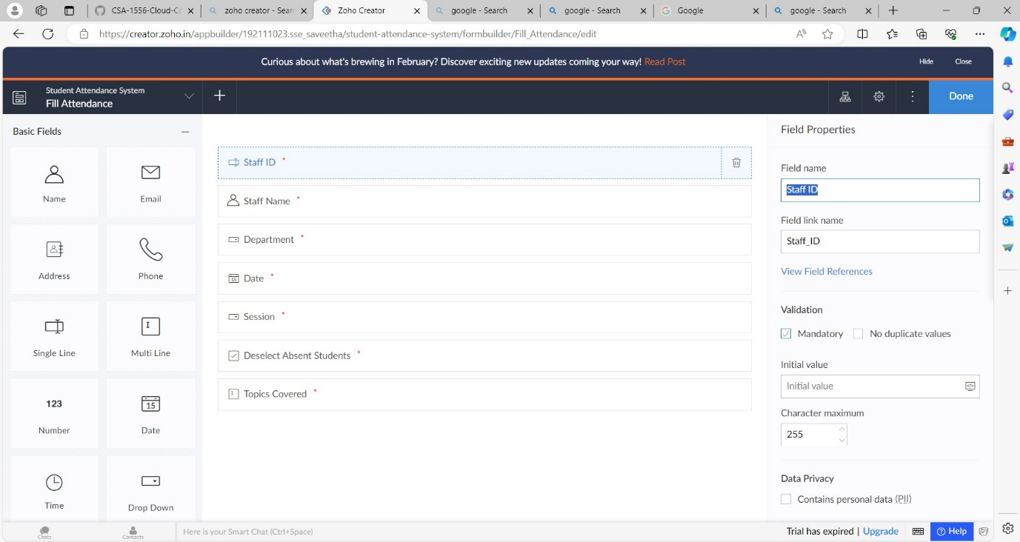

STEP 8: Enter the details of the Attendance.



STEP 9: The report has been registered in the Attendance form report.

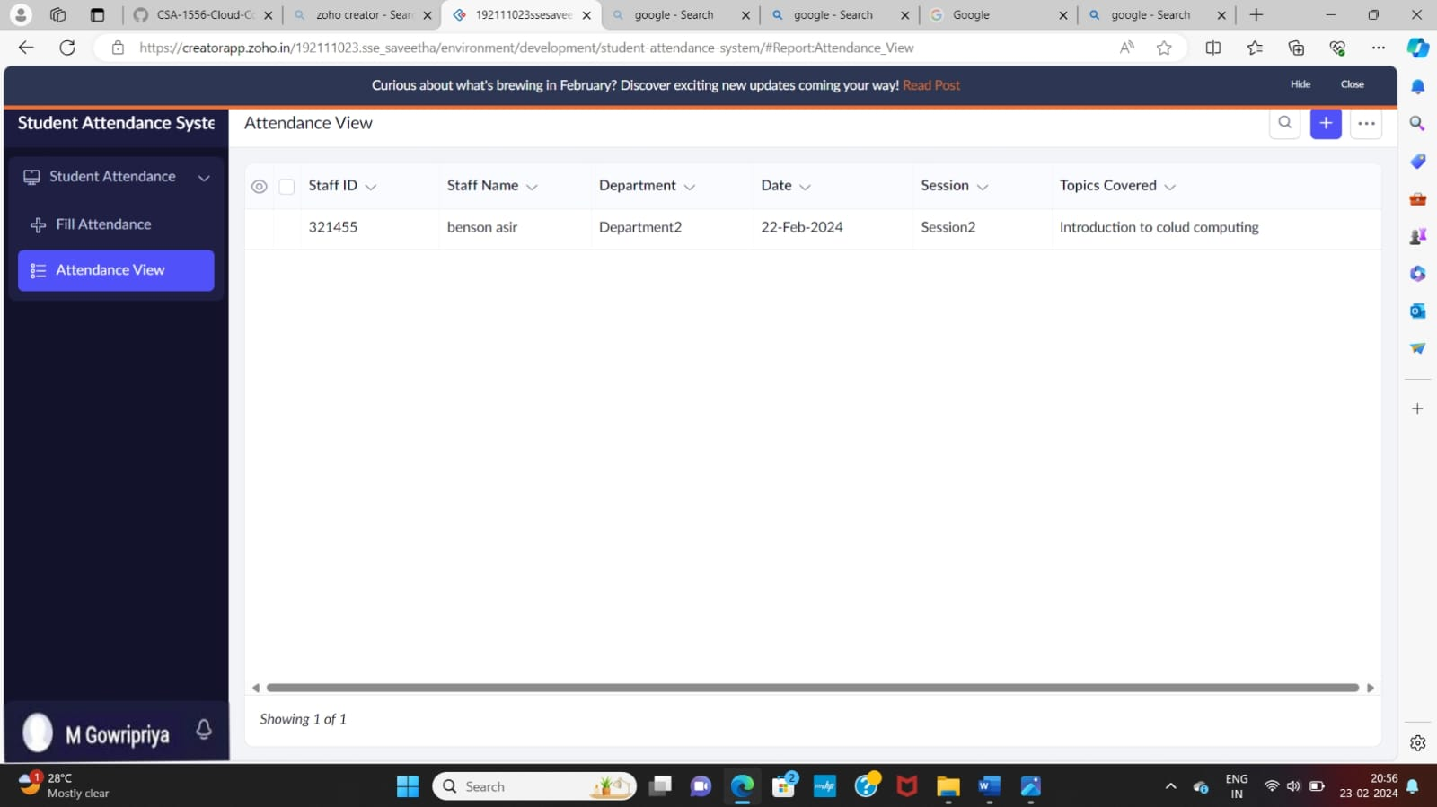

STEP 10: The form has been created as apply for leave.

Choose the fields.

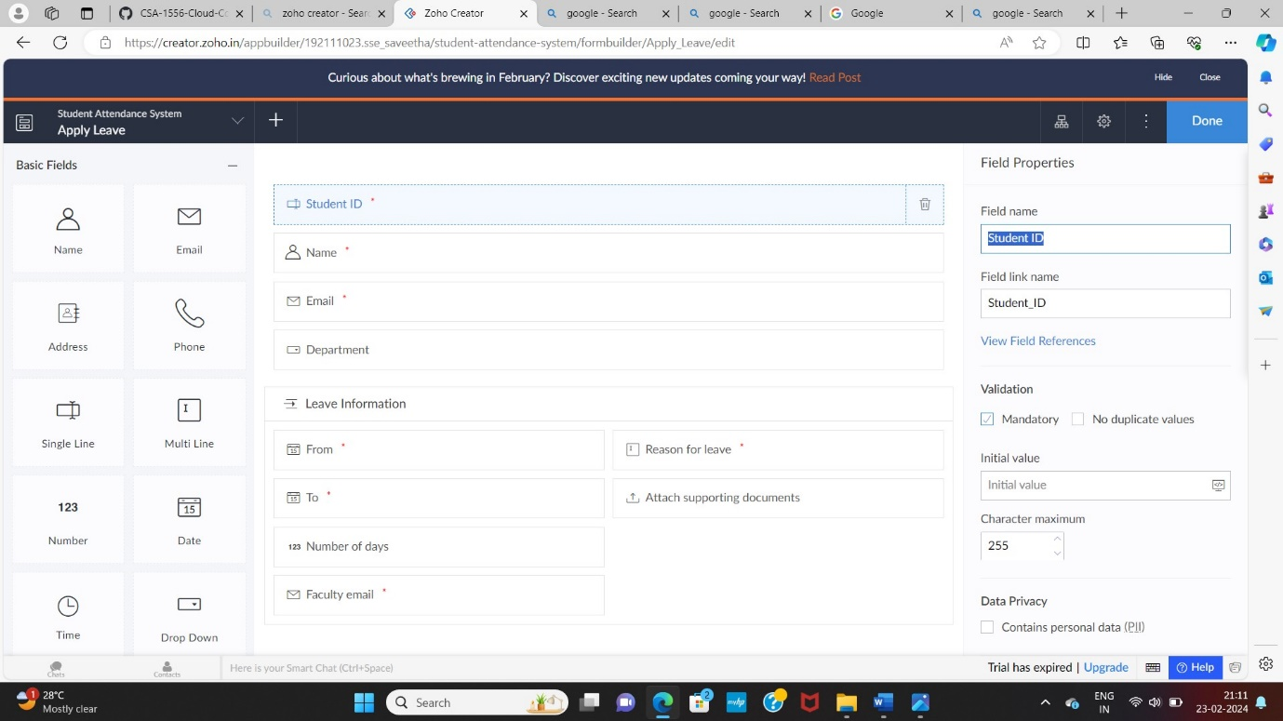

STEP 11: Enter the details of the leave.

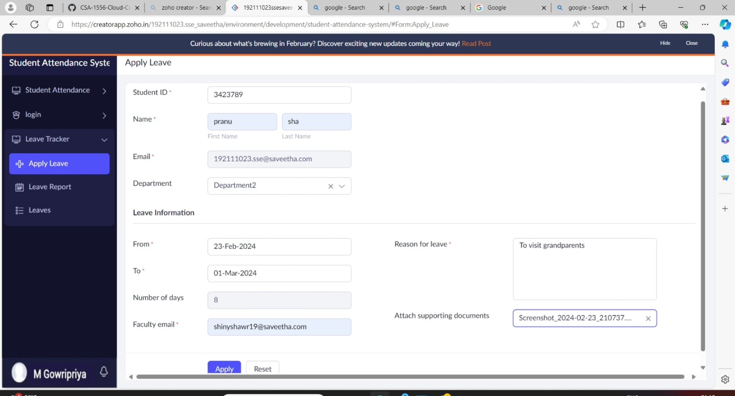

STEP 12: The report has been registered in the apply leave form report.

